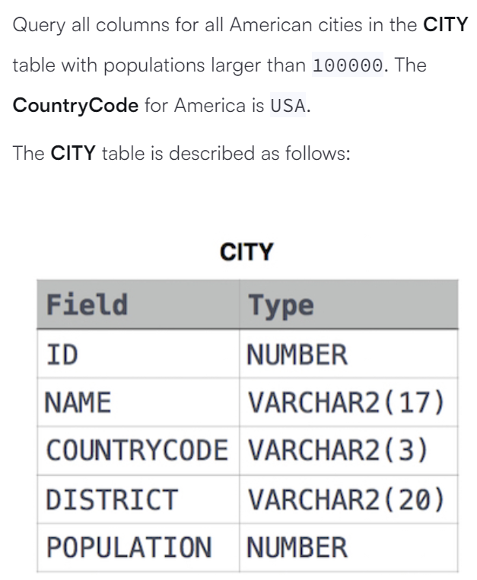**Que. 1**

**Solution:-**

**Que. 2**

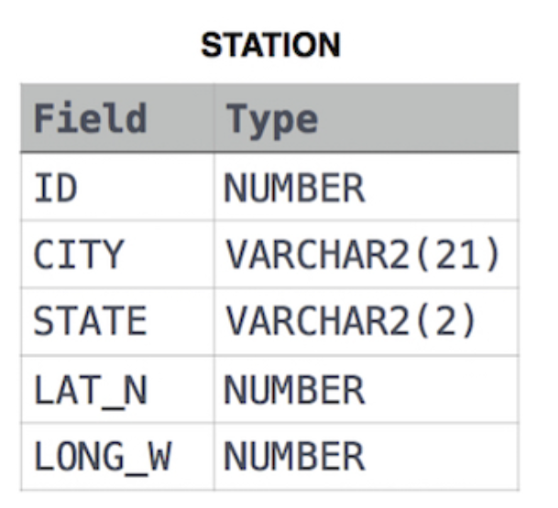

**Solution:**

**Que. 3**

**Solution**: